Arabic home page

URL :

<https://aicportal/ar/Pages/default.aspx>

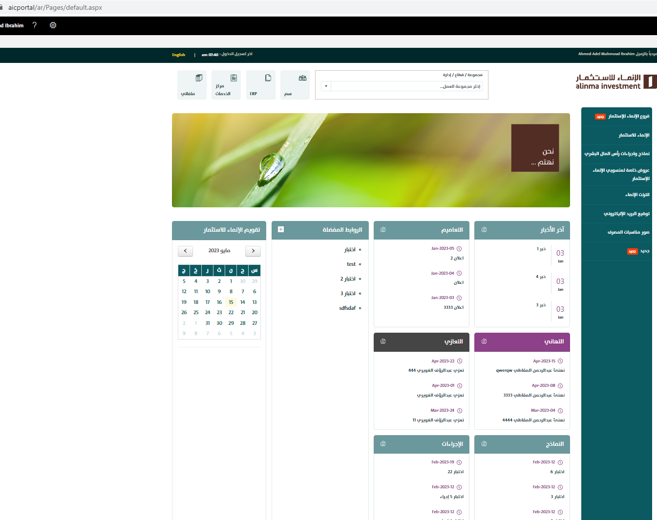

English Home page

URL:

<https://aicportal/en/pages/default.aspx>

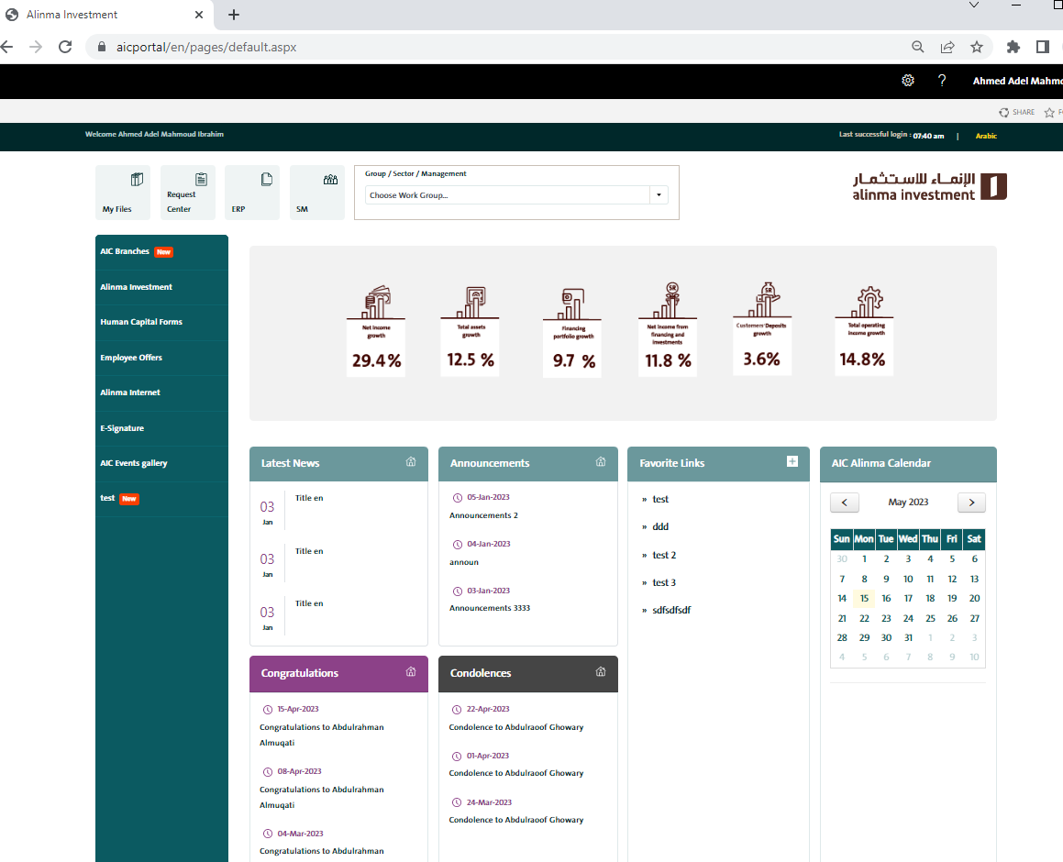

* **Group / Sector / Management**

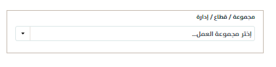

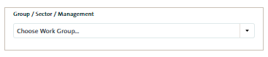

* 1. Go to this link <https://aicportal/ar/Pages/Forms/AllItems.aspx?RootFolder=%2Far%2FPages%2FAIC%5FGroups&FolderCTID=0x01200062E6F56FEDF2C445B9C1B4A32E354943&View=%7B1FBDE925%2DEBF2%2D435B%2DBD69%2DE366DC0F1389%7D>

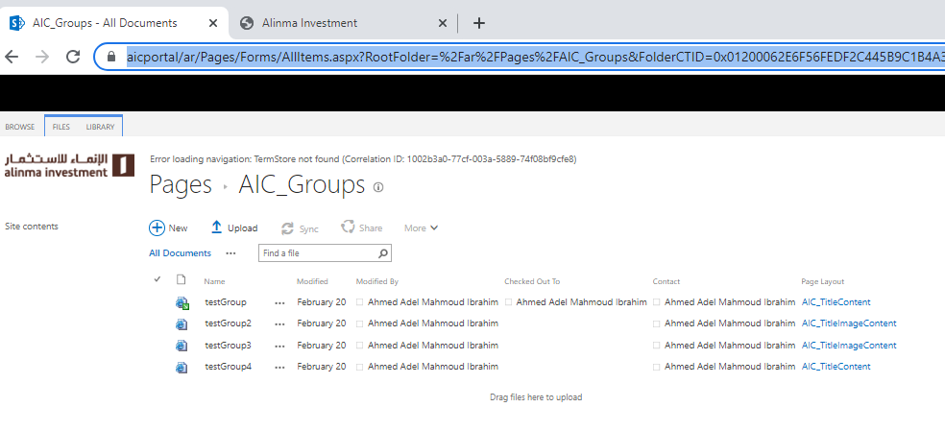

* 1. From files >> new document >> page

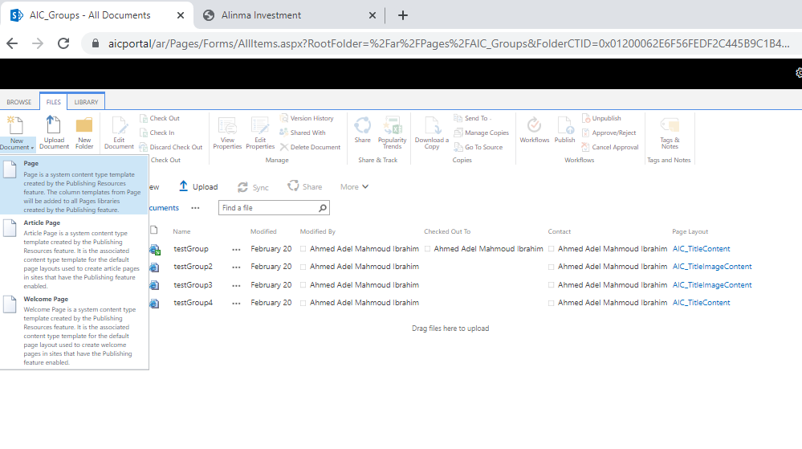

* 1. Enter the following :
     1. page title
     2. URL name
     3. Layout
        1. (Article Page) AIC_Layouts/AIC_TitleContent
        2. (Article Page) AIC_Layouts/AIC_TitleImageContent
     4. Press button Create

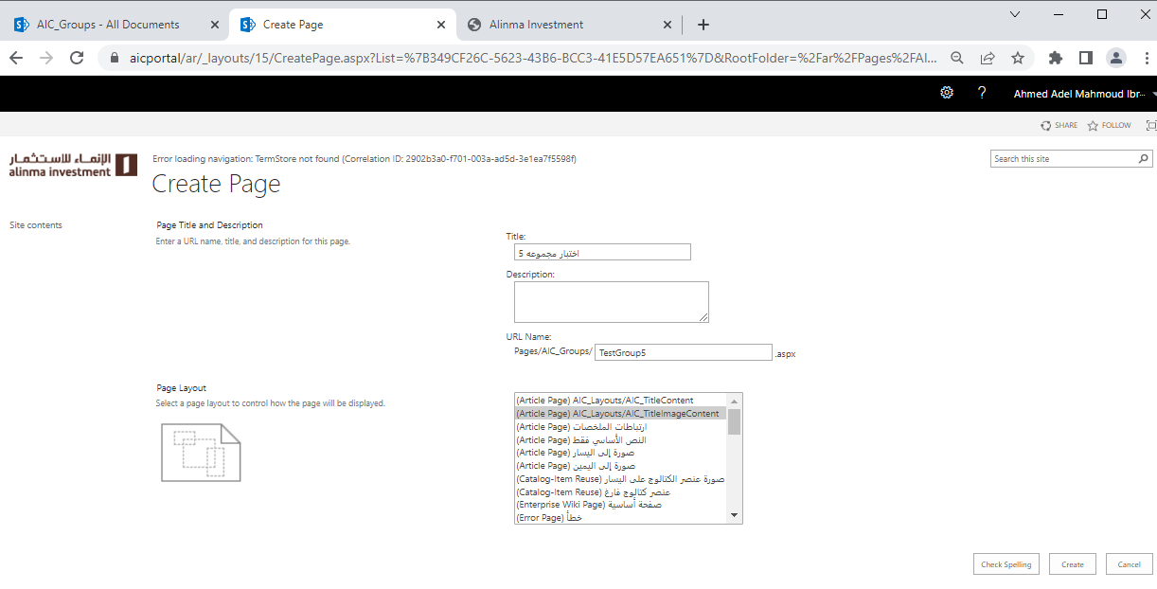

* 1. Go to new page

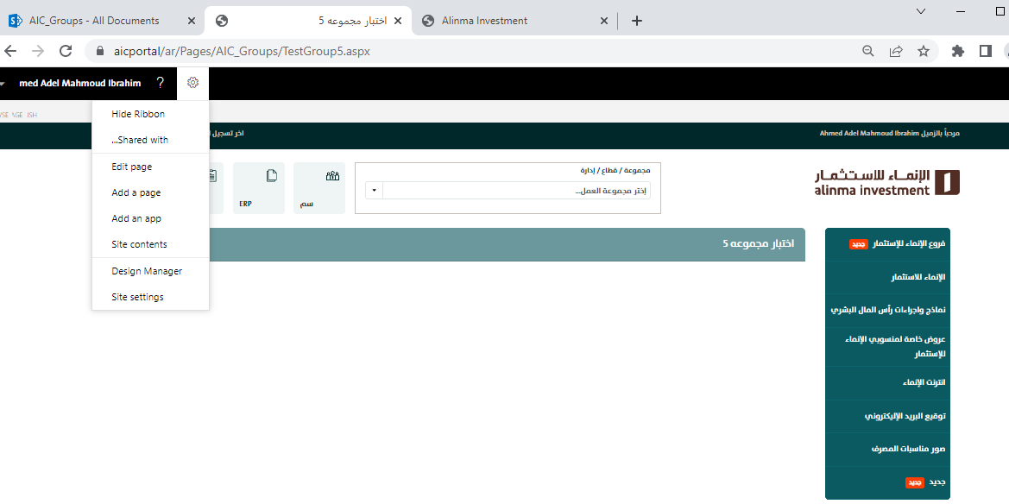

* + 1. Click edit page
    2. Update content

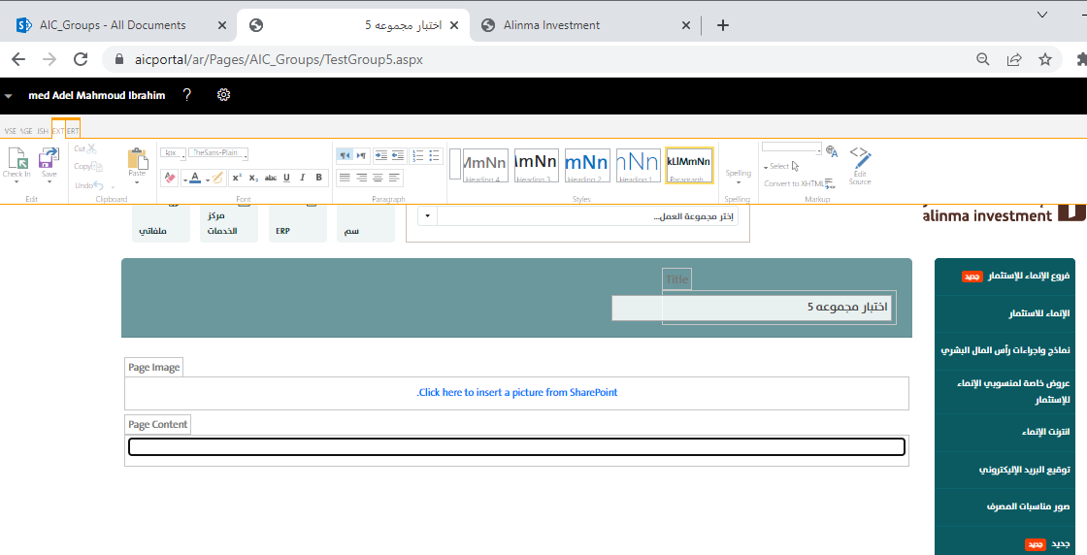

* + 1. Check in & Publish
  1. Copy page URL to use it later
  2. Add the same page on English site go to link <https://aicportal/en/Pages/Forms/AllItems.aspx?RootFolder=%2FEn%2FPages%2FAIC%5FGroups&FolderCTID=0x012000F91714E1537A154C9A7E07E41156D669&View=%7B6BF5E6B7%2D7853%2D41D8%2DA8FE%2DC27B1EE08C55%7D>
  3. Do the same previous steps and remember to the same URL Name
  4. Go to this link

<https://aicportal/ar/Lists/AIC_Groups/AllItems.aspx>

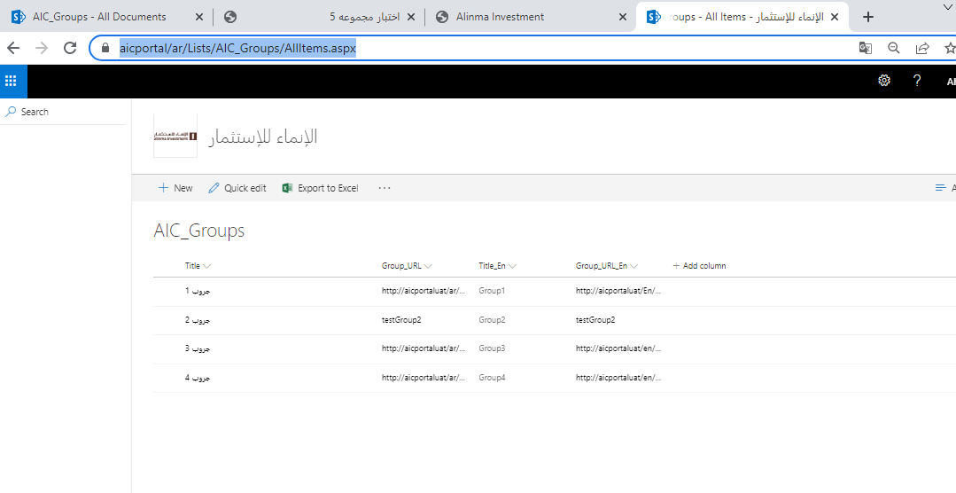

* 1. Click new >> add
     1. Title for Arabic page
     2. Group_URL for Arabic page
     3. Title_En for English page
     4. Group_URL_En for English page
     5. Save

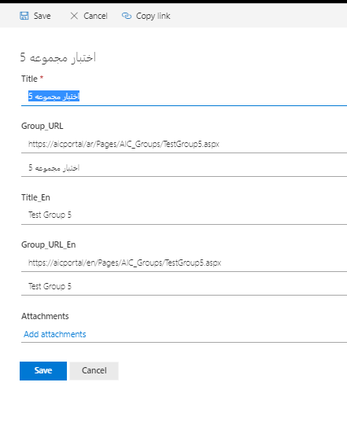

* 1. Now it’s added to groups drop down list

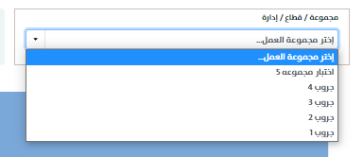

* 1. When you select a group it will redirect to the group page
* **Banners**

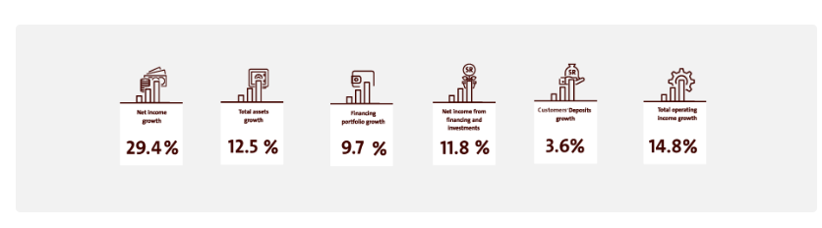

* 1. Go to this link

<https://aicportal/ar/Banners/Forms/AllItems.aspx>

* 1. New >> picture

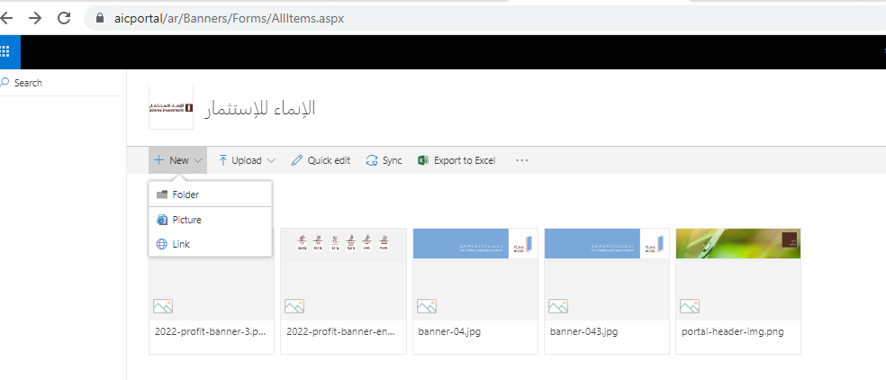

* 1. Choose a picture and upload it

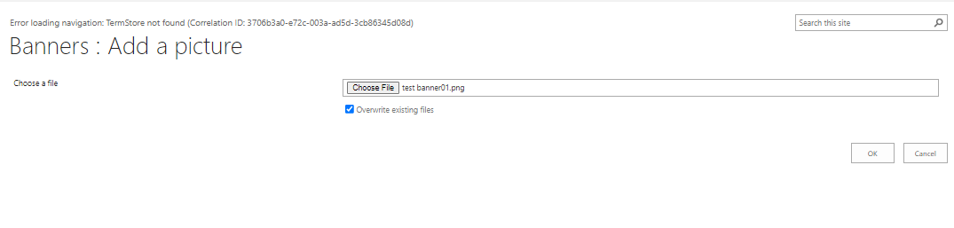

* 1. Enter name, select publish (yes), language(Arabic or English) and press save

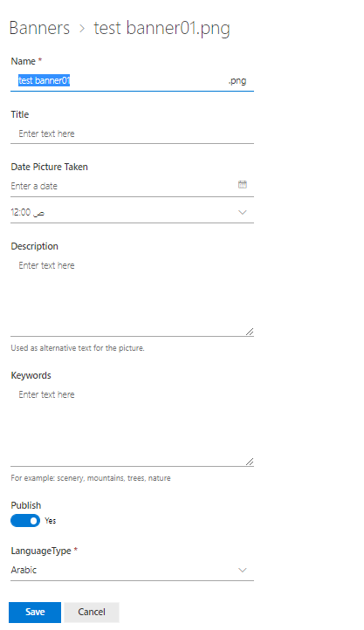

* 1. You need to add one for Arabic and another for English
* **Quick links**

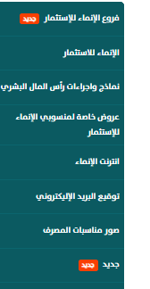

* 1. Go to link <https://aicportal/ar/Lists/QuickLinks/AllItems.aspx>

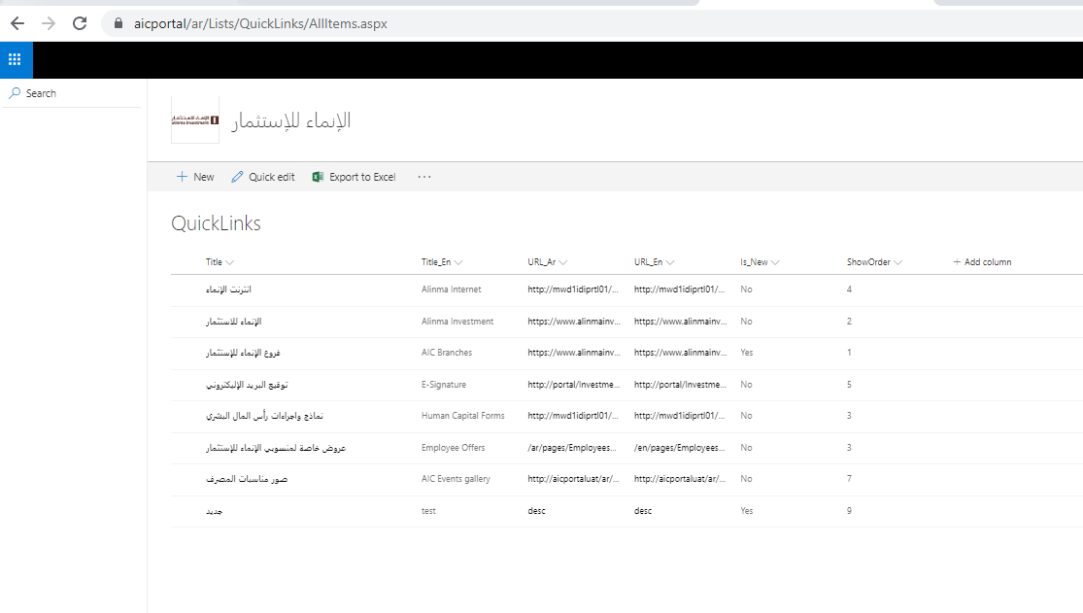

* 1. Click new

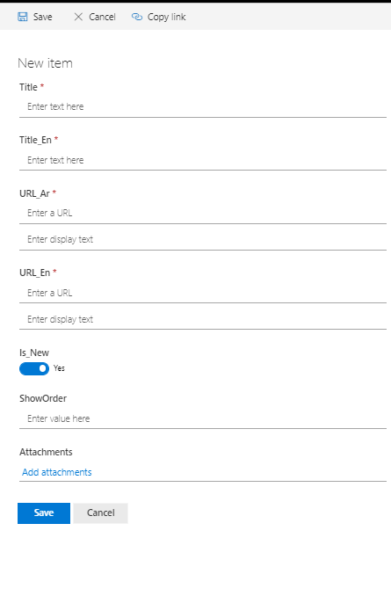

* 1. Enter Data
     1. Title : Arabic title
     2. Title_En : English title
     3. URL_Ar : url for Arabic link
     4. URL_En : url for English link
     5. Is_New : to show this icon beside link  
     6. ShowOrder : number for appearance order
* **Latest News**

[**https://aicportal/en/News/Pages/default.aspx**](https://aicportal/en/News/Pages/default.aspx)

[**https://aicportal/ar/news/pages/default.aspx**](https://aicportal/ar/news/pages/default.aspx)

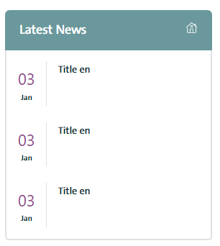

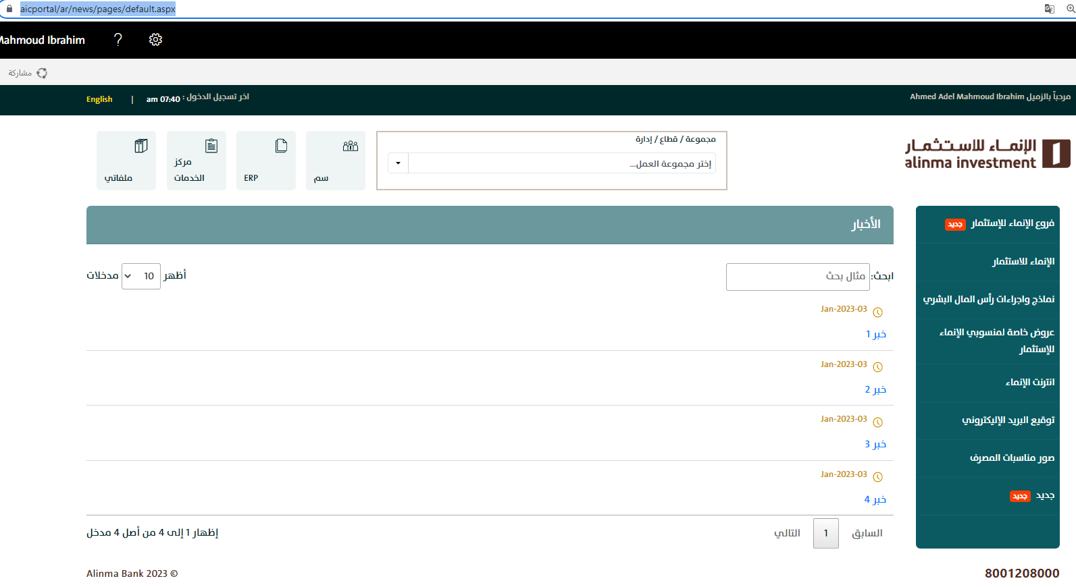

* 1. Go to this link <https://aicportal/ar/news/Lists/AIC_News/AllItems.aspx>

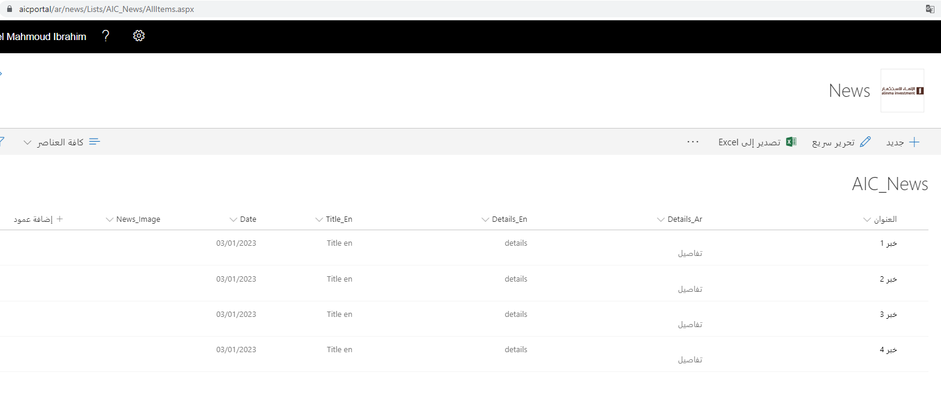

* 1. Click new ‘جديد’

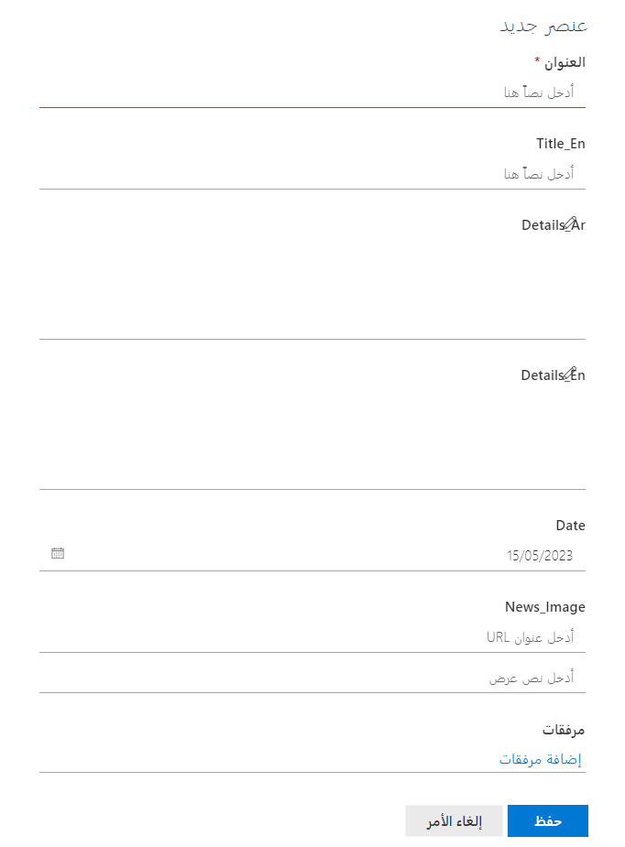

* 1. Enter all data
  2. Save
* **Announcements**

[**https://aicportal/en/Announcements/Pages/default.aspx**](https://aicportal/en/Announcements/Pages/default.aspx)

[**https://aicportal/ar/Announcements/Pages/default.aspx**](https://aicportal/ar/Announcements/Pages/default.aspx)

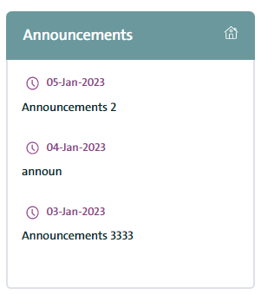

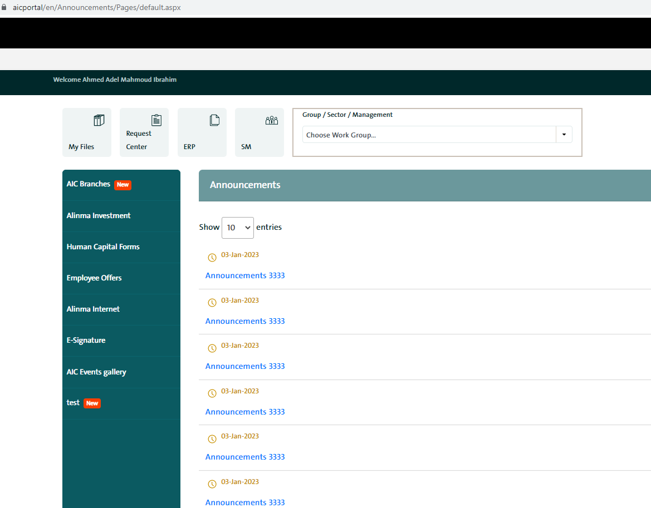

1. Go to link <https://aicportal/ar/Announcements/Lists/AIC_Announcements/AllItems.aspx>

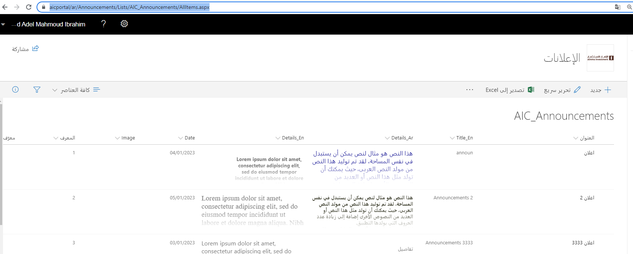

1. Click new
2. Enter all Data

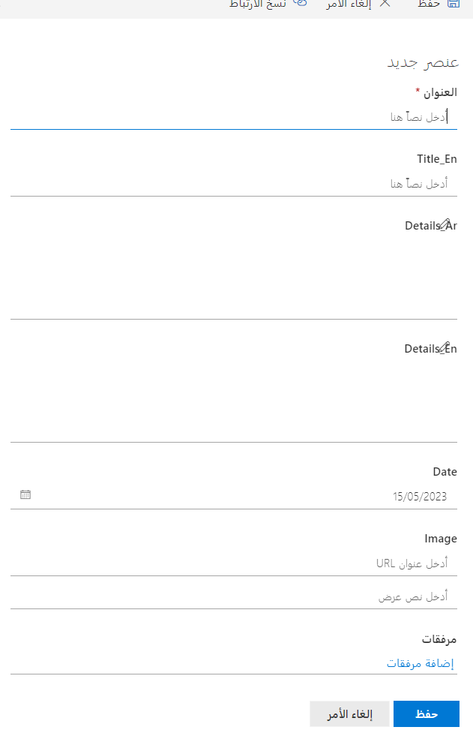

* **Congratulations**

[**https://aicportal/en/Announcements/Pages/CongratulationsHome.aspx**](https://aicportal/en/Announcements/Pages/CongratulationsHome.aspx)

[**https://aicportal/ar/Announcements/Pages/CongratulationsHome.aspx**](https://aicportal/ar/Announcements/Pages/CongratulationsHome.aspx)

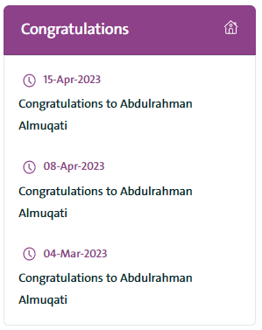

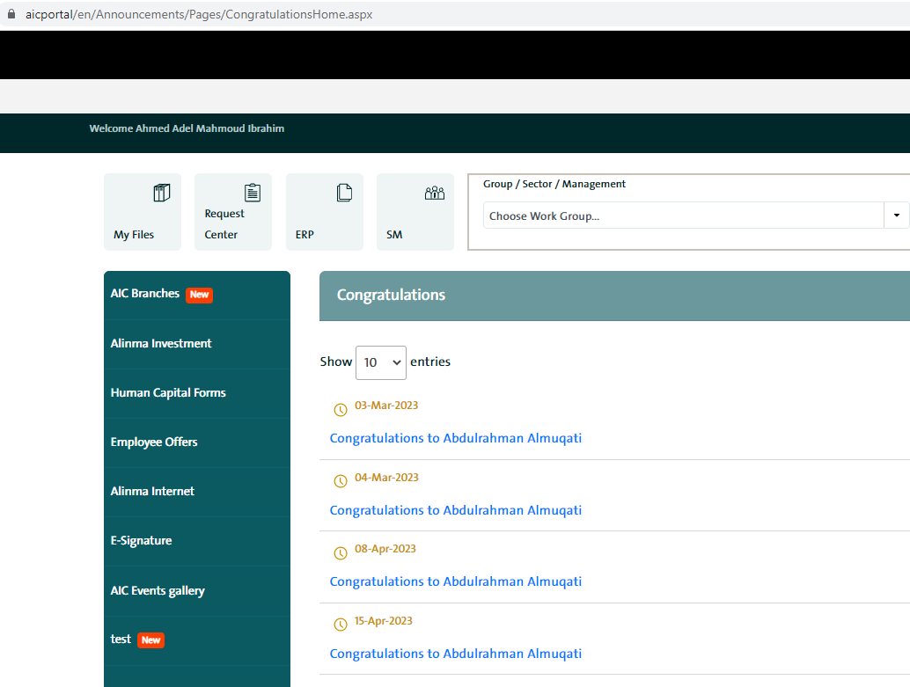

1. Go to link <https://aicportal/ar/Announcements/Lists/AIC_Congratulations/AllItems.aspx>

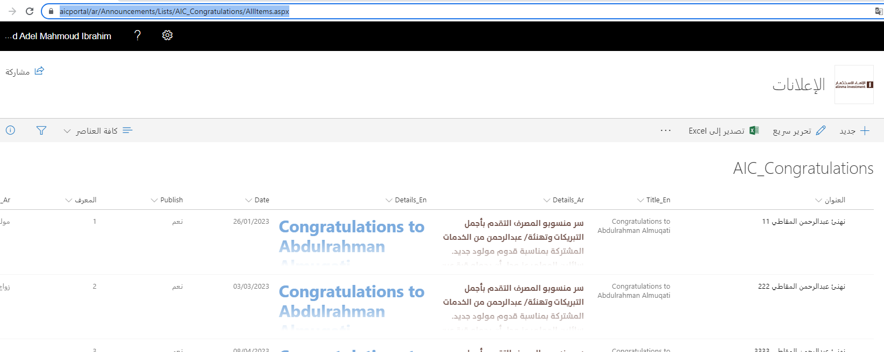

1. Enter all data

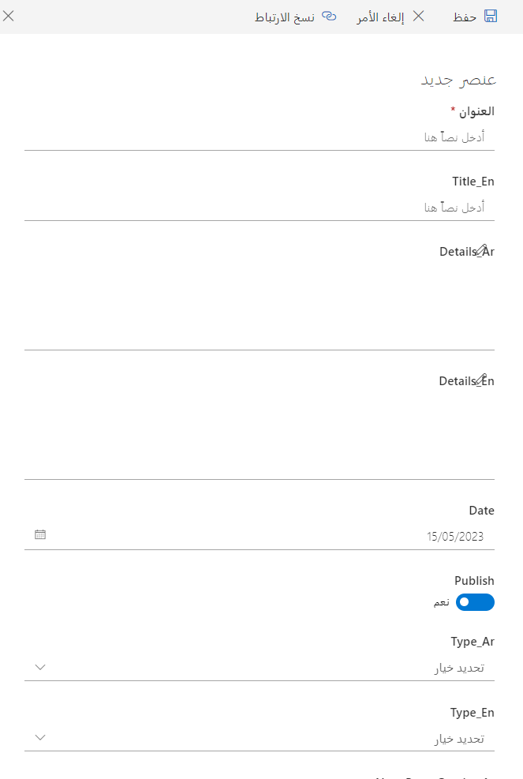

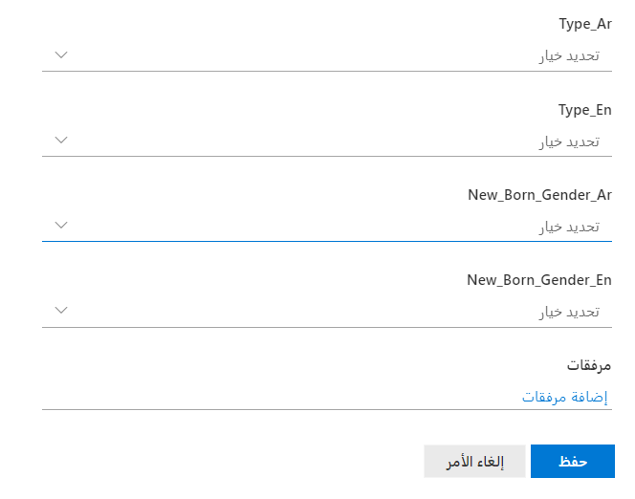

1. Click save

* **Condolences**

<https://aicportal/en/Announcements/Pages/CondolencesHome.aspx>

<https://aicportal/ar/Announcements/Pages/CondolencesHome.aspx>

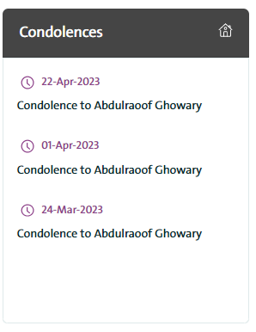

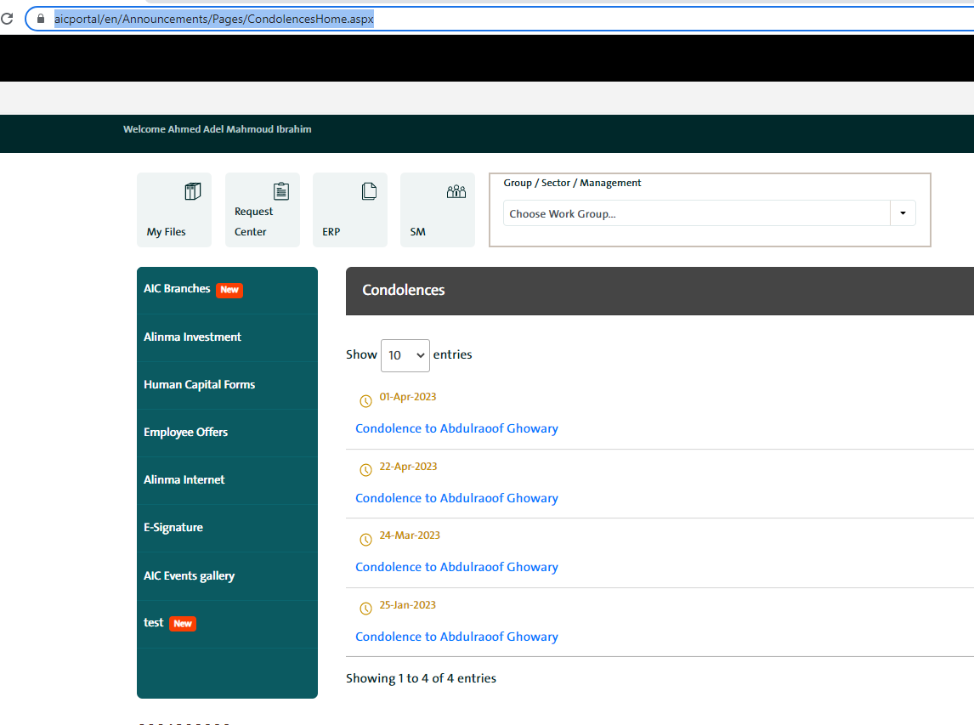

1. Go to link <https://aicportal/ar/Announcements/Lists/AIC_Condolences/AllItems.aspx>

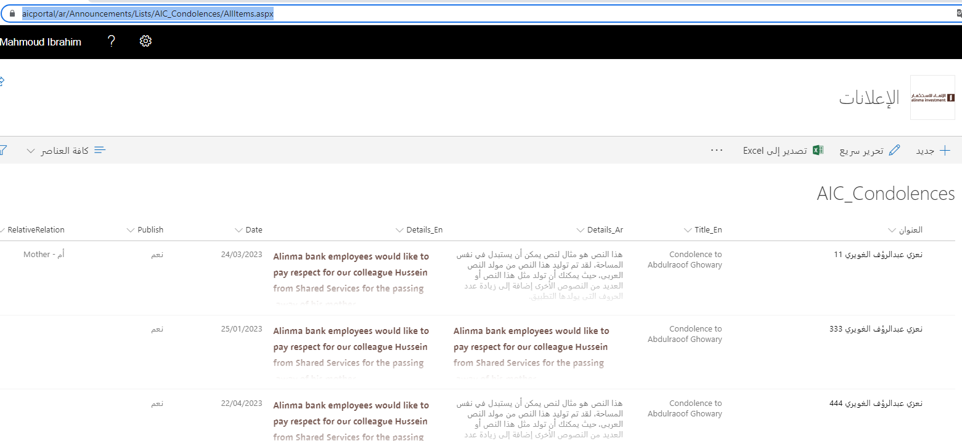

1. Enter all data

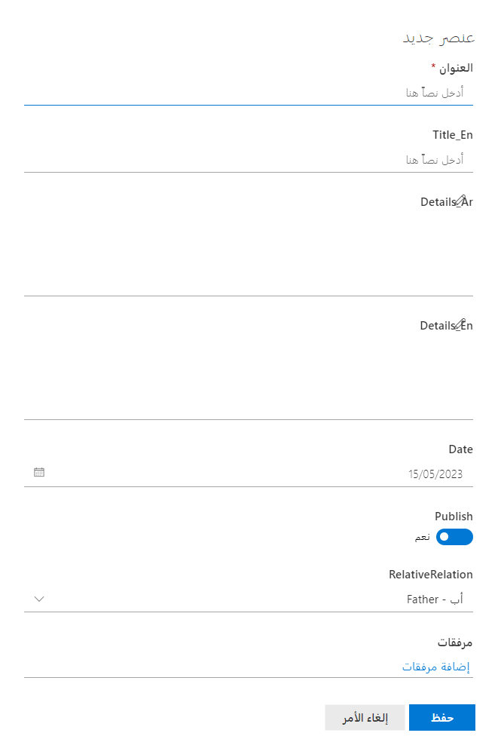

1. Click save

* **Forms**

[**https://aicportal/en/Pages/Forms.aspx**](https://aicportal/en/Pages/Forms.aspx)

[**https://aicportal/ar/Pages/Forms.aspx**](https://aicportal/ar/Pages/Forms.aspx)

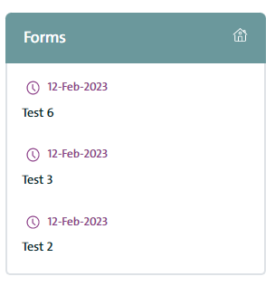

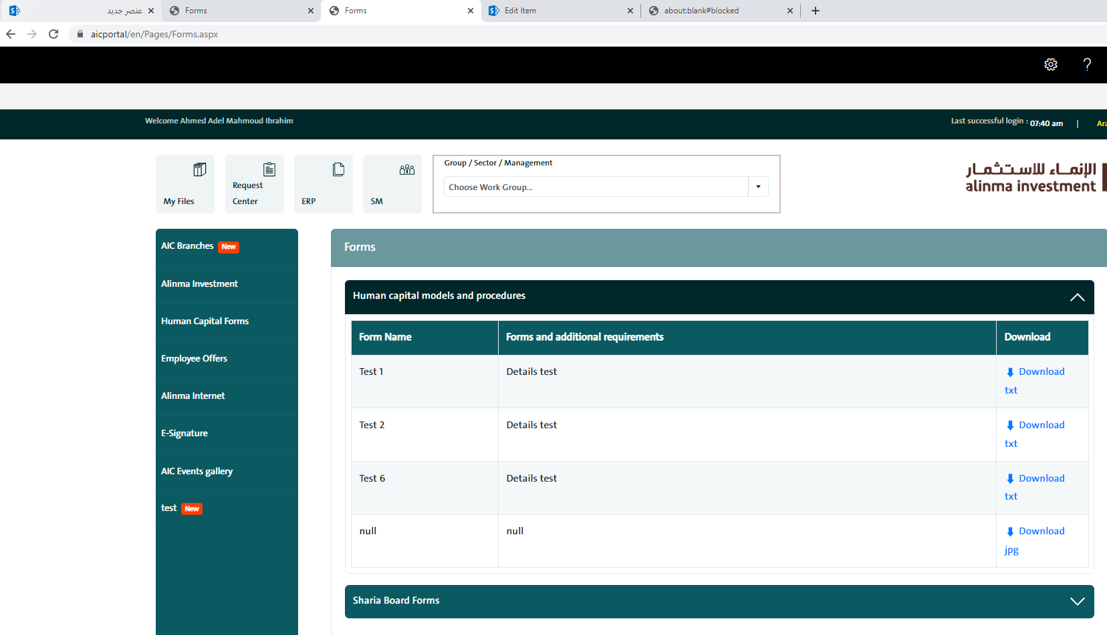

1. Go to link <https://aicportal/ar/ProceduresForms/Forms/AllItems.aspx>
2. Click upload >> files >> choose file

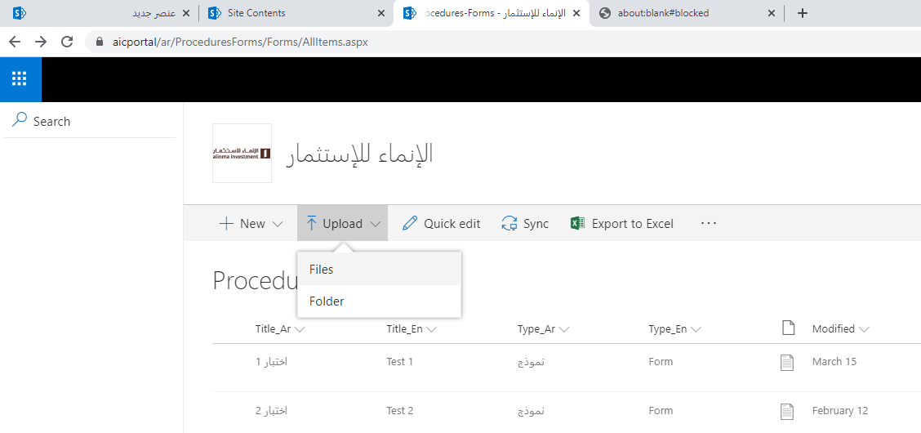

1. After upload file >> click edit all >> enter other needed data

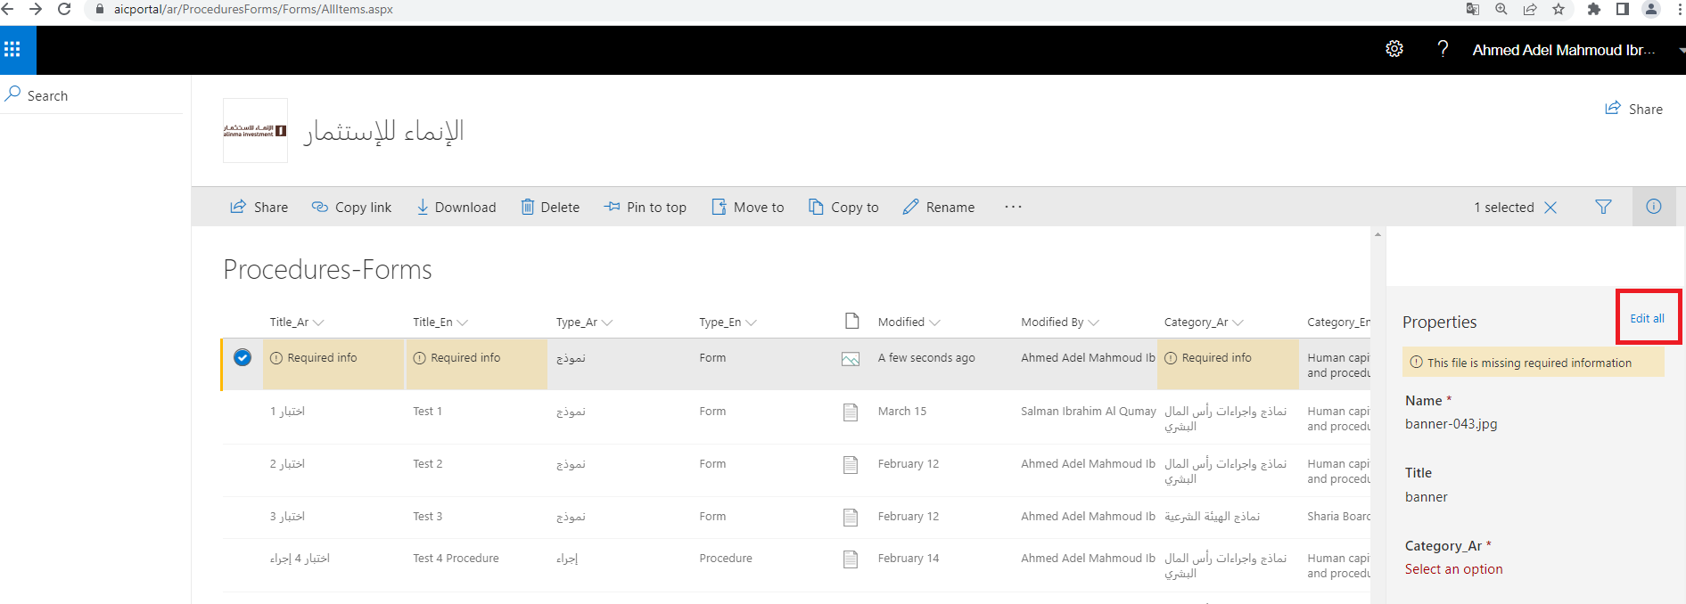

1. Enter all Data
   1. Type_ar ‘نموذج’
   2. Type_en ‘Form’

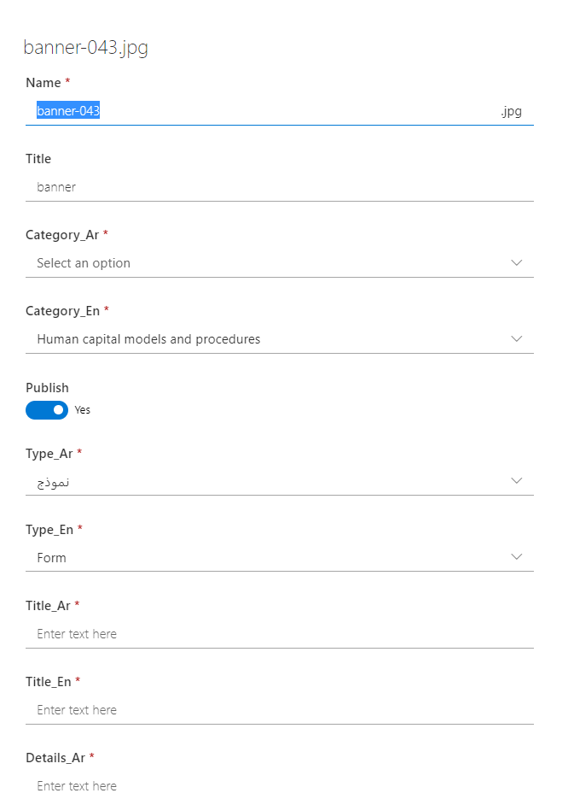

1. Press Save

* **Procedures**

[**https://aicportal/en/Pages/Forms.aspx?FormTypeId=2**](https://aicportal/en/Pages/Forms.aspx?FormTypeId=2)

[**https://aicportal/ar/Pages/Forms.aspx?FormTypeId=2**](https://aicportal/ar/Pages/Forms.aspx?FormTypeId=2)

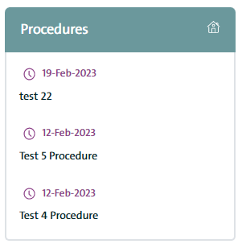

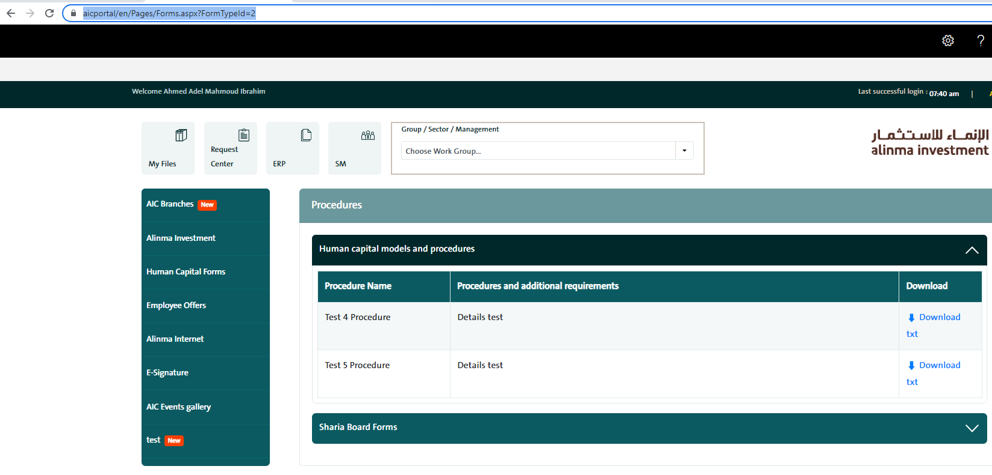

1. Go to link <https://aicportal/ar/ProceduresForms/Forms/AllItems.aspx>
2. Click upload >> files >> choose file



1. After upload file >> click edit all >> enter other needed data



1. Enter all Data
   1. Type_ar ‘إجراء’
   2. Type_en ‘procedure’



1. Press Save

* **AIC Alinma Calendar**

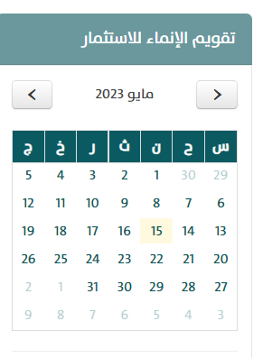

1. Go to link <https://aicportal/ar/Lists/InvestmentCalendar/calendar.aspx>
2. Choose date you want and click Add

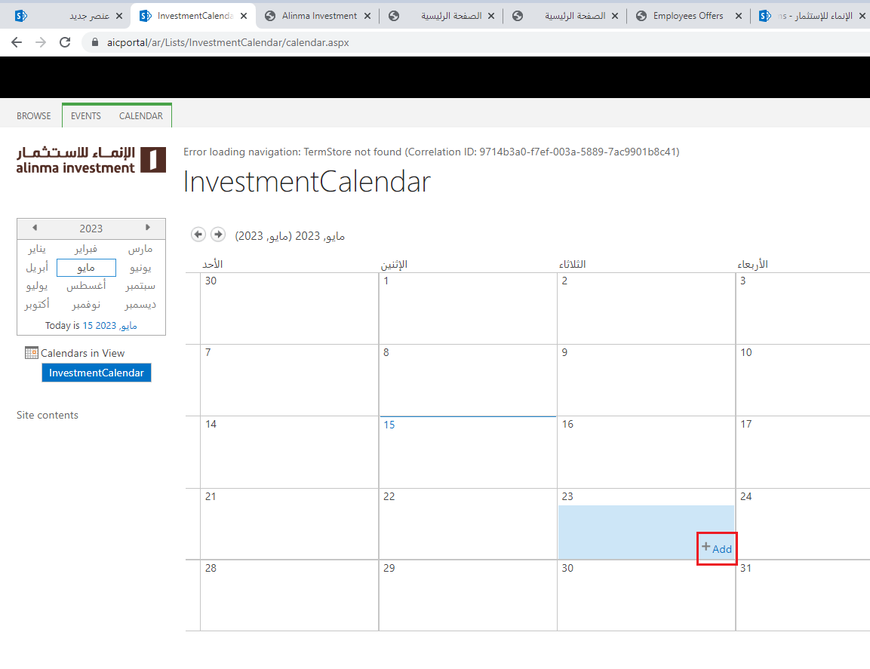

1. Fill data

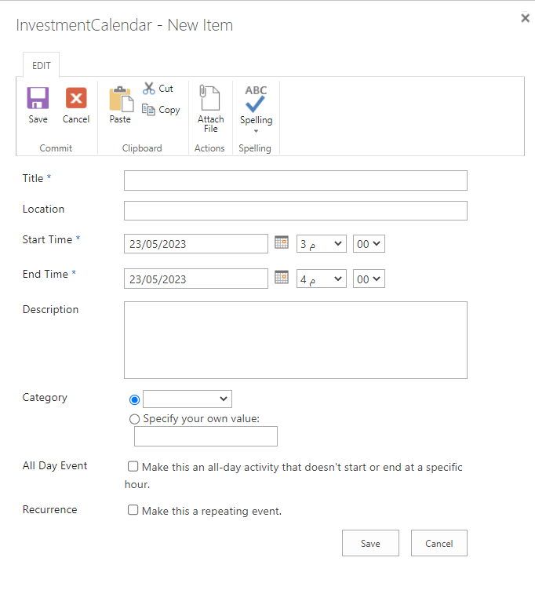

1. Press Save

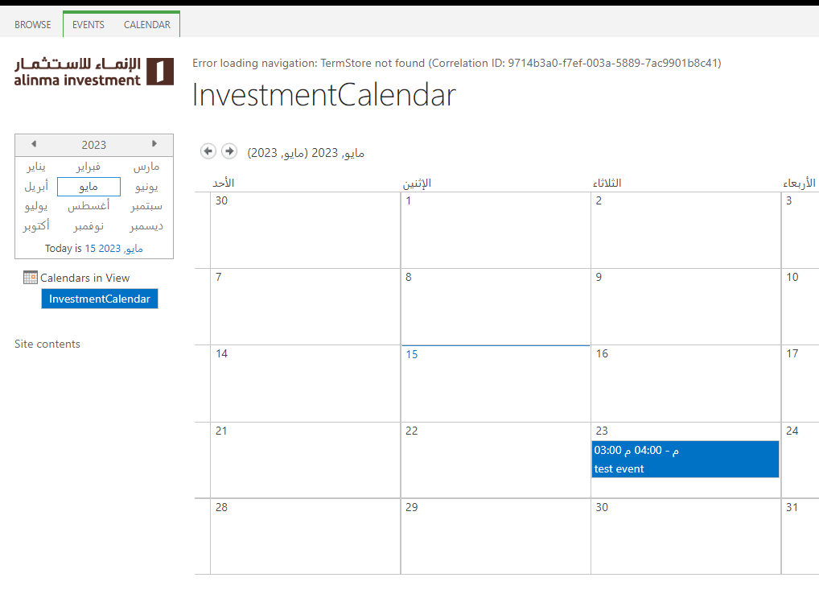

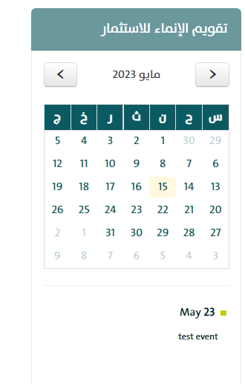

* **Favorite Links** **AIC**

1. Click on add Button

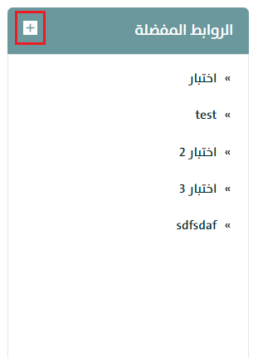

1. Fill data

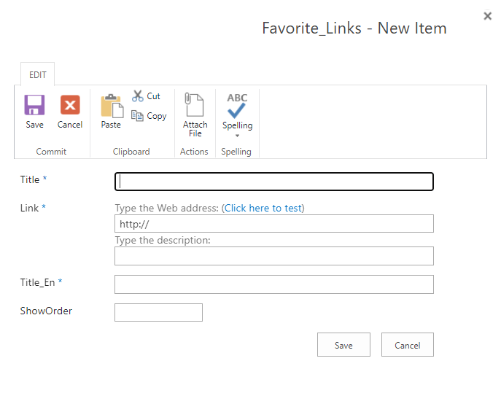

1. Press save

* **Events gallery**

<https://aicportal/ar/Gallery/Pages/default.aspx>

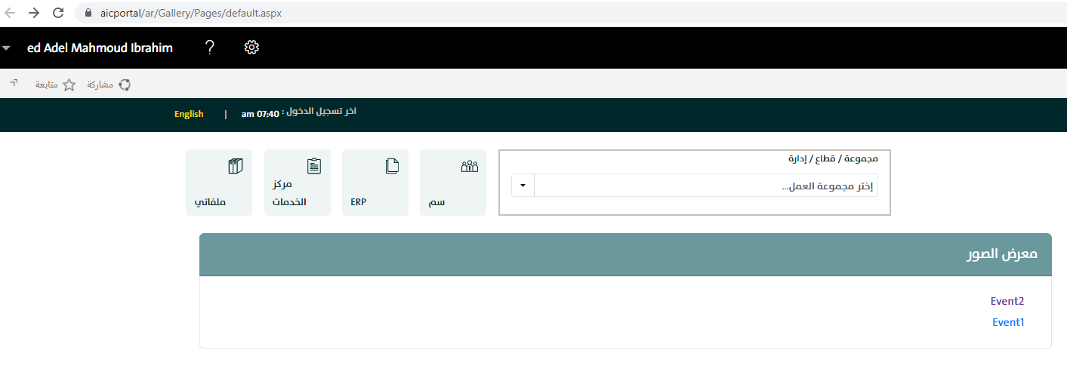

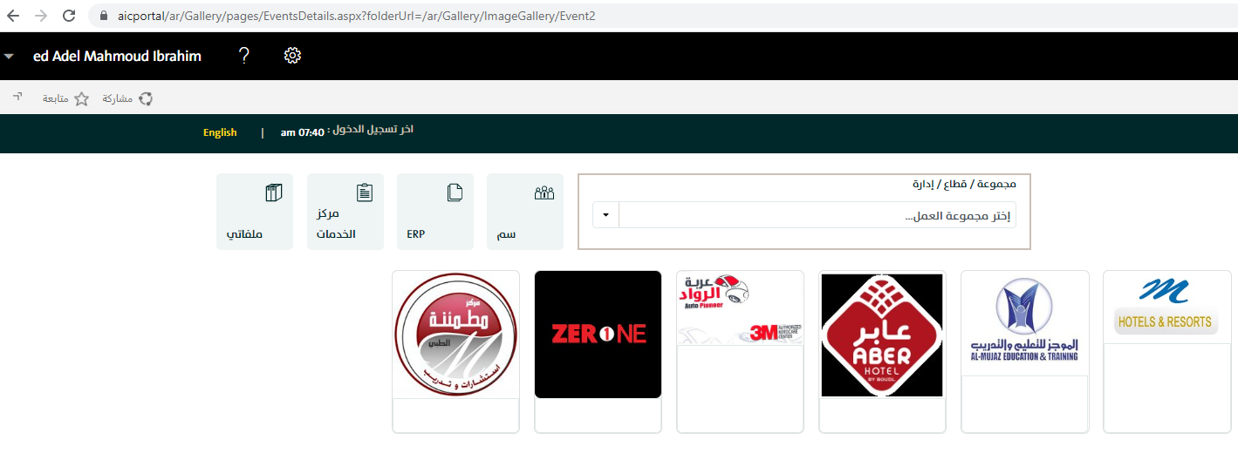

1. Go to link <https://aicportal/ar/Gallery/ImageGallery/Forms/AllItems.aspx>
2. Click new >> folder

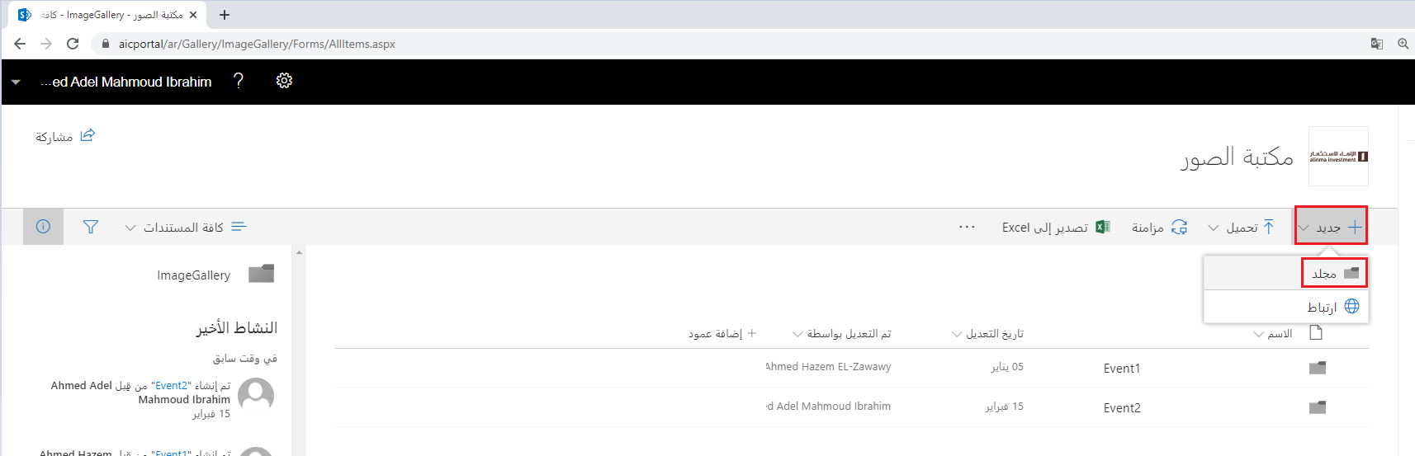

1. Enter folder name

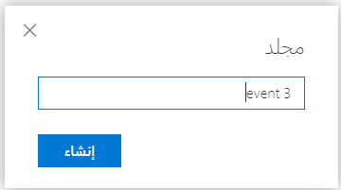

1. Click create
2. Click upload >> files

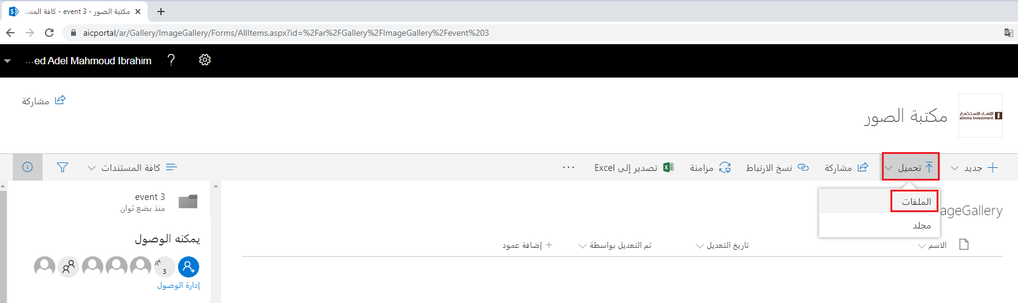

1. Go back to <https://aicportal/ar/Gallery/Pages/default.aspx> and click on new added folder

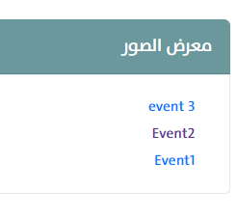

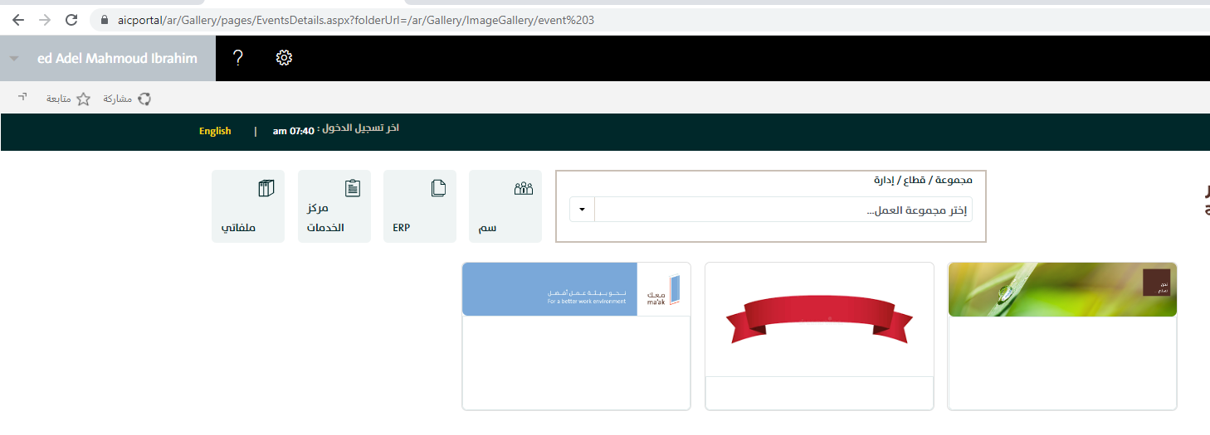

* **Employee Offers**

[**https://aicportal/ar/pages/EmployeesOffers.aspx**](https://aicportal/ar/pages/EmployeesOffers.aspx)

[**https://aicportal/en/pages/EmployeesOffers.aspx**](https://aicportal/en/pages/EmployeesOffers.aspx)

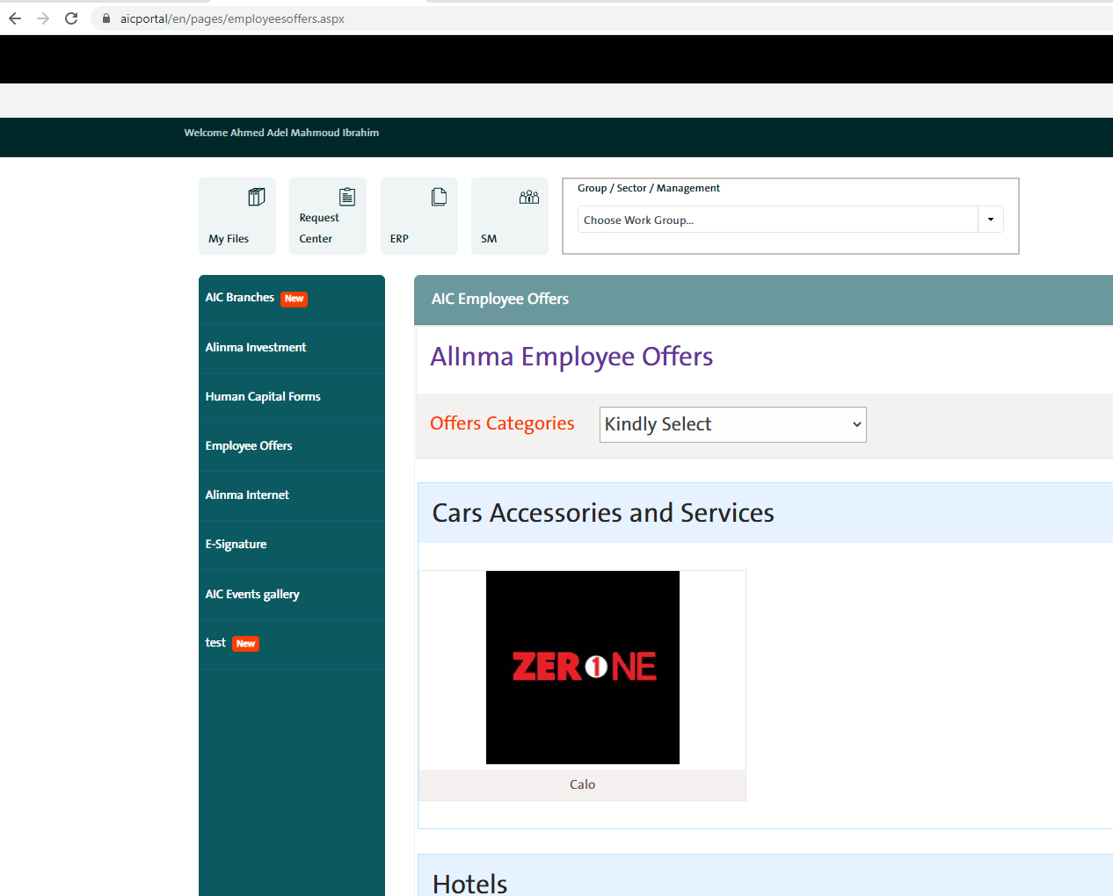

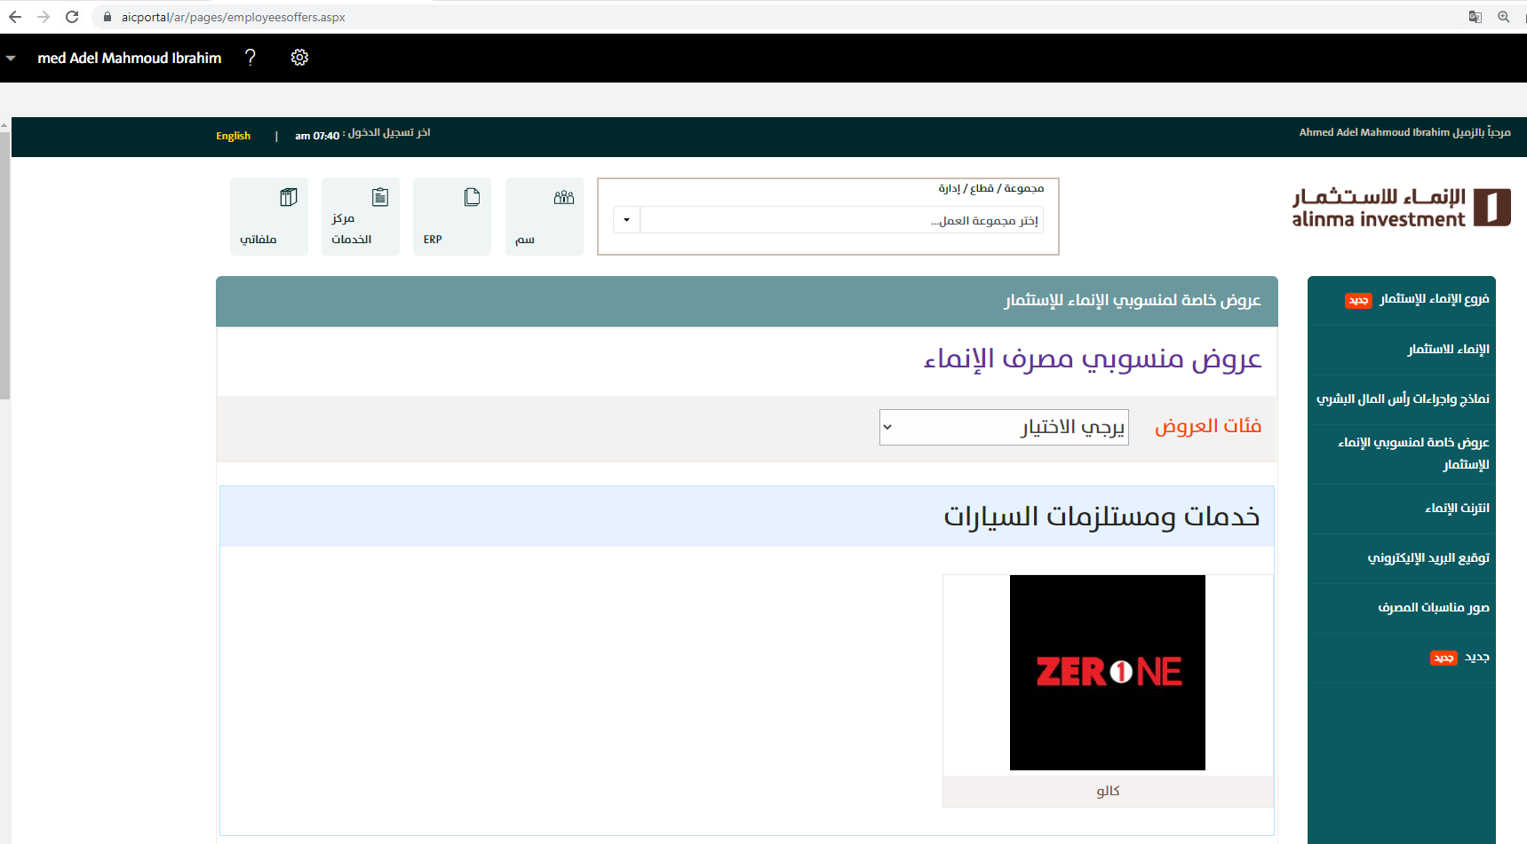

1. Add logo for employees offer >> go to link <https://aicportal/ar/OffersLogo/Forms/AllItems.aspx>
2. Click upload >> files

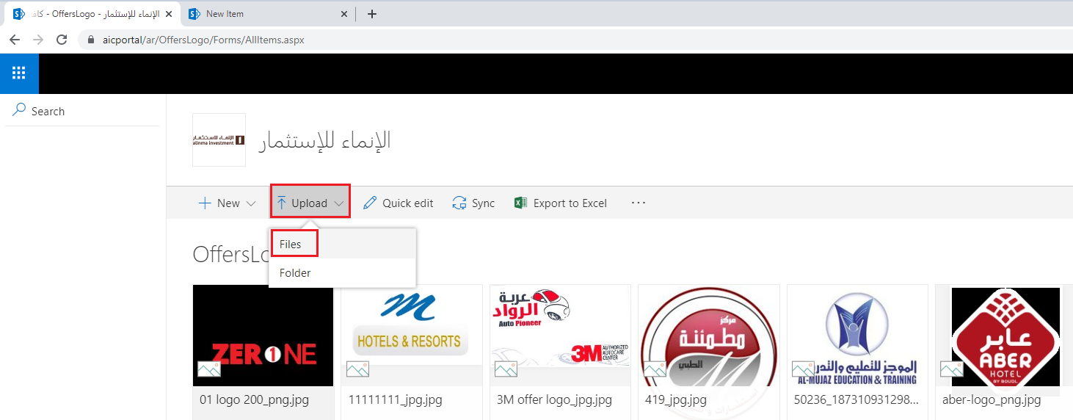

1. right click on new added image >> copy link (to use it later on employee offer data ‘image logo’)
2. Go to link <https://aicportal/ar/Lists/EmployeesOffers/AllItems.aspx>

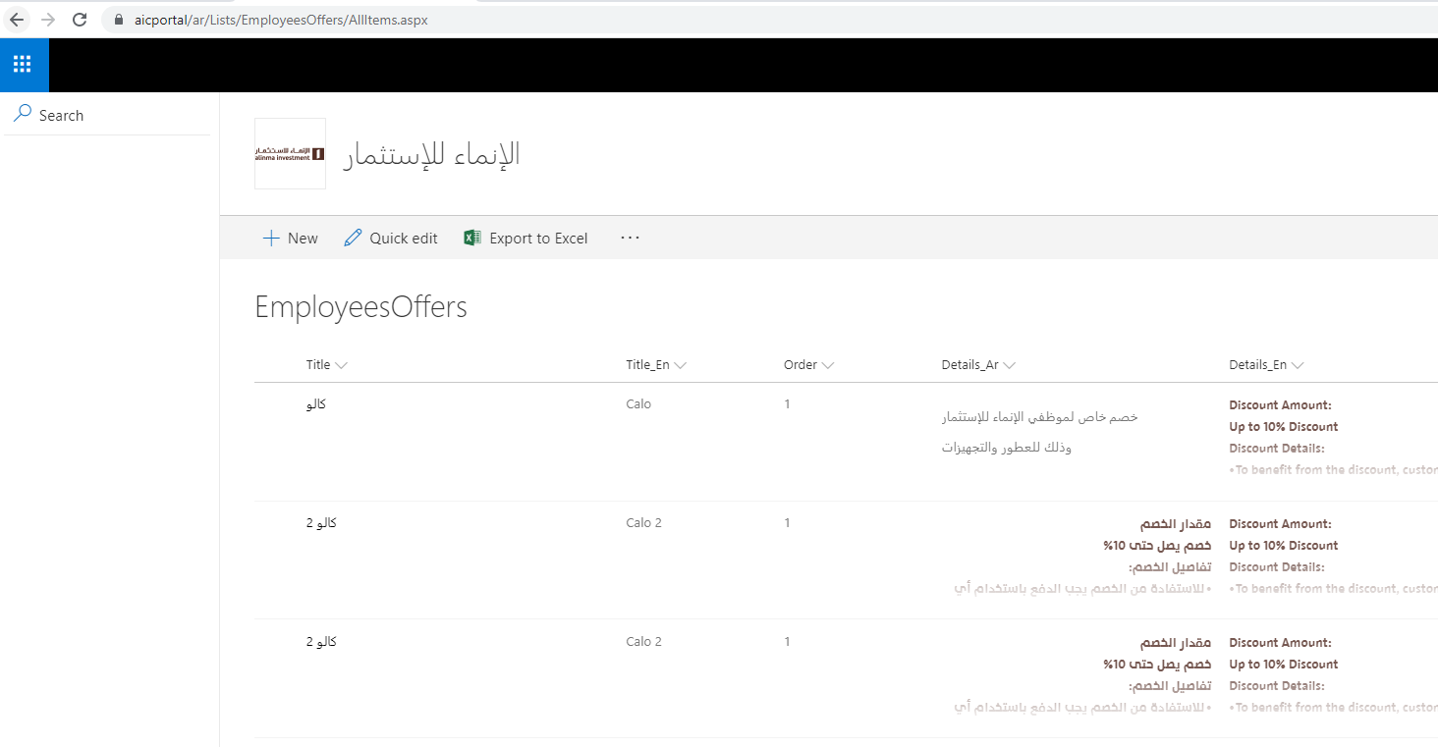

1. press new
2. enter all data (use copied link before on logo field)

